# INTERNET OF THINGS

# PROJECT 8. PUBLIC TRANSPORT OPTIMIZATION

### OBJECTIVES:

The main objective of public transport optimization is to enhance the efficiency, accessibility, and sustainability of public transportation systems.

### COMPONENTS :

1.MQTT(Message Queuing Telemetry Transport).

2.AMQP(Advanced Message Queuing Protocol).

3.Webhooks.

4.Websocket.

5.DB Write.

### STEPS FOR OPTIMIZING PUBLIC TRANSPORT :

Step1: DATA COLLECTION: Gather data on passenger demand, routes, and travel patterns.

Step2: ANALYSIS: Analyze the data to identify inefficiencies and areas for improvement.

Step3: ROUTE PLANNING: Optimize bus and train routes to minimize travel time and congestion.

Step4: SCHEDULING: Create efficient timetables to maximize service during peak hours .

Step5: INTEGRATION: Ensure seamless connections between different modes of public transport.

Step6: TECHNOLOGY: Implement real-time tracking and mobile apps for passenger information.

Step7: INFRASTRUCTURE: Invest in improvements like clean energy options.

Step8: ACCESSIBILITY: Ensure accessibility for all passengers, including those with disabilities.

### PYTHON CODE FOR OPTIMIZATION:

import networkx as nx

# Create a transportation network as a graph

G = nx.Graph()

# Add nodes representing stops or locations

G.add_node("A")

G.add_node("B")

G.add_node("C")

G.add_node("D")

# Add edges representing connections and distances

G.add_edge("A", "B", weight=5)

G.add_edge("B", "C", weight=3)

G.add_edge("A", "C", weight=8)

G.add_edge("C", "D", weight=2)

# Find the shortest path between two locations

start = "A"

end = "D"

shortest_path = nx.shortest_path(G, start, end, weight="weight")

shortest_distance = nx.shortest_path_length(G, start, end, weight="weight")

print(f"Shortest path from {start} to {end}: {shortest_path}")

print(f"Shortest distance: {shortest_distance}")

### PICTURE REPRESENTATION:

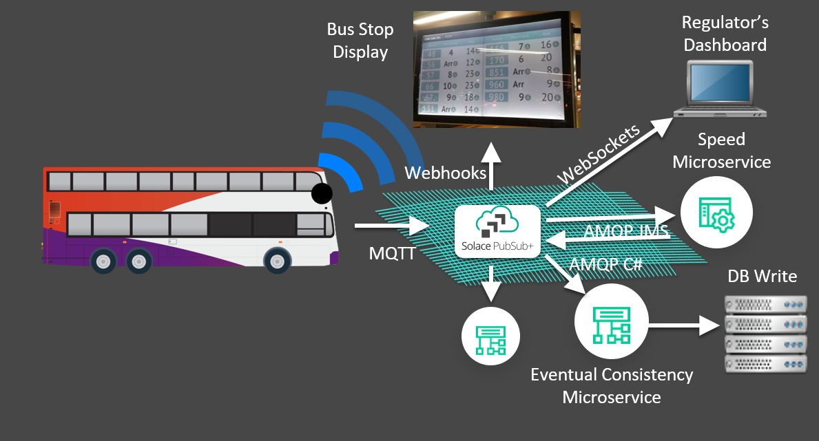

### BENEFITS:

1. REDUCED TRAFFIC CONGESTION: Efficient public transport systems can reduce the number of private vehicles on the road, easing traffic congestion in cities.

2. ENVIRONMENTAL BENEFITS: Less reliance on individual vehicles leads to reduced greenhouse gas emissions and improved air quality.

3. COST SAVINGS: Public transport can be more cost-effective for individuals than owning and maintaining a private vehicle.

4. ACCESSIBILITY: Improved public transport makes it easier for people without cars, including low- income individuals and seniors, to access jobs, education, and services.

5. QUALITY OF LIFE: Public transport enhance the quality of life by reducing commuting stress and improving overall urban mobility.

### FEATURES:

1. REAL TIME TRACKING: Implement GPS and mobile apps for real-time tracking of buses, trams, and trains.

2. INTEGRATED FARE SYSTEM: Create seamless fare payment systems that work across multiple modes of transportation, such as buses, subways, and ferries.

3. DATA ANALYTICS: Utilize data analytics to monitor and predict passenger demand, enabling better route planning and resource allocation.

4. DYNAMIC SCHEDULLING: Adjust schedules in real-time based on demand, traffic conditions, and events, reducing wait times and improving service reliability.

5. TRANSIT HUBS: Develop transportation hubs where different modes of transport intersect, making it easier for passengers to switch between them.